**PNM Logo.png**

**Certificate of Attendance**

This is to certify that

\_\_\_\_\_\_\_\_\_\_\_\_\_\_\_\_\_\_\_\_\_\_\_\_\_\_\_\_\_

has satisfactorily completed one training hour entitled:

# 

# New Proposed Healthier CACFP Meal Standards:

# What You Need to Know

# January 29, 201FRAC logo_darkblue gray.jpg5 1 Credit Hour

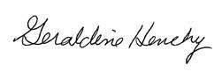

Geraldine Henchy, MPH, RD

Food Research and Action Center

[www.frac.org](http://www.frac.org)